

**Kubernetes Cluster Deployment and Static Website Monitoring Using Prometheus, Grafana, and Splunk**

Synopsis submitted in fulfillment of the requirement for the degree of Bachelor of Technology

**Bachelor of Technology**

**In**

**Computer Science and Engineering**

**By**

**SACHIN VISHWAKARMA**

**Roll No: 23**

**Reg. No: 12107934**

Submitting to:

**Dr. Varsha sahni**

**Lovely Professional University**

**Phagwara, Punjab**

**Table of Contents**

1. Introduction
2. Problem Statement  
     • Profile of the Problem  
     • Rationale/Scope of the Study  
     • Feasibility Analysis  
     • Project Plan
3. Software Requirement Analysis  
     • Introduction  
     • General Description  
     • Specific Requirements
4. Design  
     • System Design  
     • Design Notations  
     • Detailed Design  
     • Flowcharts  
     • Pseudo Code
5. Implementation  
     • Implementation of the Project  
     • Conversion Plan  
     • Post-Implementation and Software Maintenance
6. Project Legacy  
     • Current Status of the Project  
     • Remaining Areas of Concern  
     • Technical and Managerial Lessons Learnt
7. Source Code or System Snapshots
8. Bibliography (References)

**1. Introduction**

This project involves the deployment of a scalable Kubernetes cluster on AWS cloud infrastructure, designed to efficiently manage containerized applications. A static website is hosted within the cluster using the NGINX web server, showcasing how lightweight web services can be deployed and managed in a cloud-native environment. To enhance observability and system reliability, the project integrates advanced monitoring and logging tools. Prometheus is used to collect real-time metrics from the Kubernetes nodes and pods, while Grafana provides interactive dashboards for visualizing these metrics, enabling effective performance monitoring. Additionally, Splunk is implemented to gather and analyze logs from across the cluster, allowing for in-depth error detection and troubleshooting. This integrated setup not only ensures high availability and performance but also offers deep insights into system operations, making it a robust example of modern DevOps and cloud-native practices.

**2. Problem Statement**

**Profile of the Problem**

Modern web applications and websites demand high availability, scalability, and robust monitoring. Traditional deployment models often struggle with scaling, centralized management, and real-time monitoring.

**Rationale/Scope of the Study**

This study aims to demonstrate the effectiveness of cloud-based container orchestration and monitoring tools in hosting and maintaining a reliable static website.

**Feasibility Analysis**

* Technical Feasibility: Kubernetes and monitoring tools are mature and supported on cloud platforms like AWS.
* Operational Feasibility: Once deployed, the system requires minimal manual intervention.
* Economic Feasibility: Using AWS Free Tier and open-source tools keeps the cost low.

**Project Plan**

1. Set up AWS EC2 instances for Master and Worker nodes.
2. Install Kubernetes and configure the cluster.
3. Deploy NGINX server hosting a static HTML website.
4. Integrate Prometheus and Grafana for metrics monitoring.
5. Configure Splunk Forwarder to send website logs to Splunk Enterprise.

**3. Software Requirement Analysis**

**Introduction**

This section defines the software requirements essential for the successful deployment and monitoring of the Kubernetes cluster.

**General Description**

The project uses open-source tools and cloud infrastructure to minimize cost and maximize learning.

**Specific Requirements**

* AWS EC2 Instances (Ubuntu OS)
* Kubernetes (kubeadm, kubelet, kubectl)
* Docker
* NGINX Server
* Prometheus
* Grafana
* Splunk Enterprise and Universal Forwarder

**4. Design**

**System Design**

The system comprises a Master Node and a Worker Node in a Kubernetes cluster hosted on AWS EC2 instances. A static website is deployed using NGINX in a pod on the Master Node. Prometheus scrapes metrics from the nodes and pods, while Grafana visualizes them. Splunk captures logs from the NGINX server using a Universal Forwarder.

**Design Notations**

* Kubernetes Components: Master (Control Plane), Worker (Node)
* Prometheus Components: Prometheus Server, Node Exporter
* Grafana Dashboard Panels
* Splunk Forwarder Configuration

**Detailed Design**

* Master Node: Manages the cluster using kubeadm. Hosts NGINX Deployment and Prometheus Operator.
* Worker Node: Joins the cluster and assists in load distribution. Hosts exporters.
* Prometheus Configuration: Scrape targets include NGINX and node exporters.
* Grafana Dashboards: JSON configuration for Kubernetes metrics dashboard imported.
* Splunk Configuration: Universal Forwarder monitors NGINX logs and forwards to Splunk Enterprise.

**Flowcharts**

1. Kubernetes Cluster Setup:

**Start → Launch EC2 Instances → Install Docker & kubeadm → Initialize Master → Join Worker → Deploy Website → Install Monitoring Tools → End**

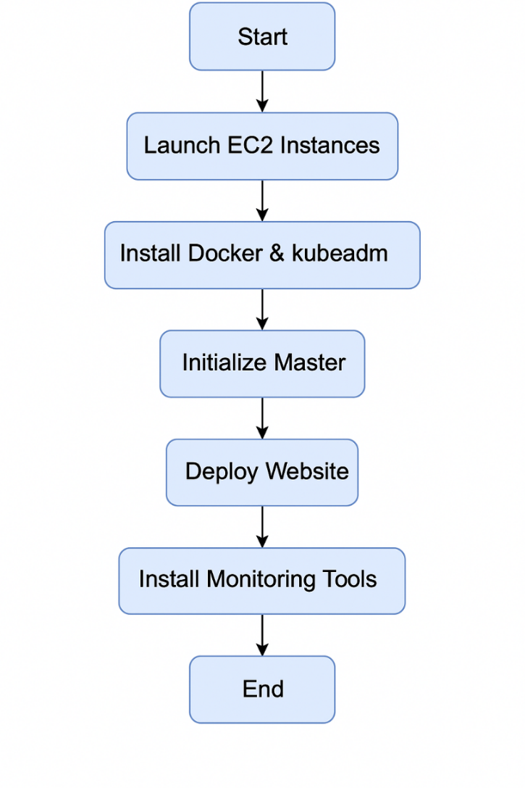

1. Monitoring Data Flow:

**NGINX Logs → Splunk Forwarder → Splunk Enterprise**

**Node Metrics → Prometheus → Grafana Dashboards**

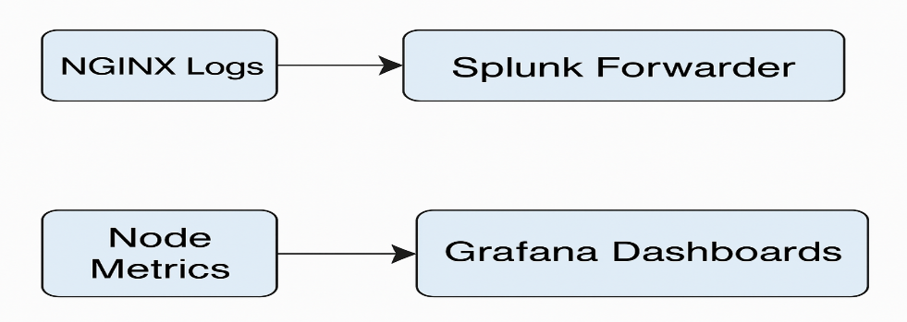

**Pseudo Code**

NGINX Deployment YAML:

apiVersion: apps/v1

kind: Deployment

metadata:

name: nginx-deployment

spec:

replicas: 1

selector:

matchLabels:

app: nginx

template:

metadata:

labels:

app: nginx

spec:

containers:

- name: nginx

image: nginx:latest

ports:

- containerPort: 80

**5. Implementation**

**Implementation of the Project**

1. Kubernetes Cluster Deployment:
   * Initialized Master Node using kubeadm init.
   * Installed Docker and Kubernetes tools on Worker Node and joined the cluster.
2. Static Website Deployment:
   * Created a Dockerfile and HTML content for the static website.
   * Deployed the website using a Kubernetes Deployment and Service with NGINX.
3. Prometheus & Grafana Setup:
   * Installed Prometheus Operator.
   * Configured ServiceMonitors and added scrape configs for NGINX and Kubernetes metrics.
   * Deployed Grafana and imported dashboards using JSON files.
4. Splunk Setup:
   * Installed Splunk Enterprise on Worker Node.
   * Installed Splunk Universal Forwarder on Master Node.
   * Configured inputs.conf to monitor /var/log/nginx/*.log.
   * Configured outputs.conf to forward logs to Splunk Enterprise.

**Conversion Plan**

As the system is built from scratch on cloud infrastructure, there is no legacy system to convert. However, a backup and restoration procedure has been documented for future upgrades or disaster recovery.

**Post-Implementation and Software Maintenance**

* Monitor the Kubernetes cluster using Grafana.
* Monitor logs and alerts via Splunk.
* Perform regular updates of system packages and Docker images.
* Add Horizontal Pod Autoscalers in case of increased traffic.

**6. Project Legacy**

**Current Status of the Project**

* Static website is successfully hosted on Kubernetes.
* Prometheus and Grafana monitor the cluster and pods.
* Splunk is receiving real-time NGINX logs.

**Remaining Areas of Concern**

* Implement TLS for NGINX and secure communications.
* Add High Availability (HA) for production-ready deployment.
* Enable alerting rules in Prometheus.

**Technical and Managerial Lessons Learnt**

* Learned cloud provisioning, container orchestration, and log management.
* Understood the importance of observability in modern DevOps environments.
* Gained experience in troubleshooting and configuring distributed systems.

**7. Source Code or System Snapshots**

* **Master’s Command:-**

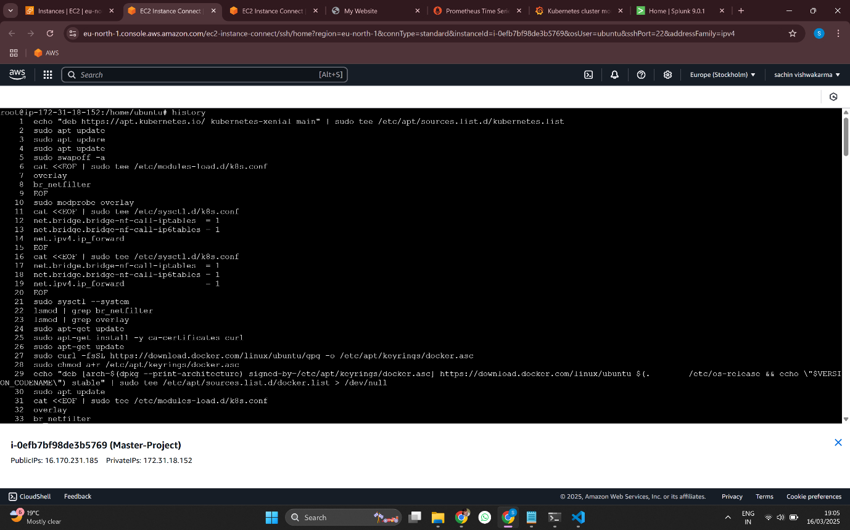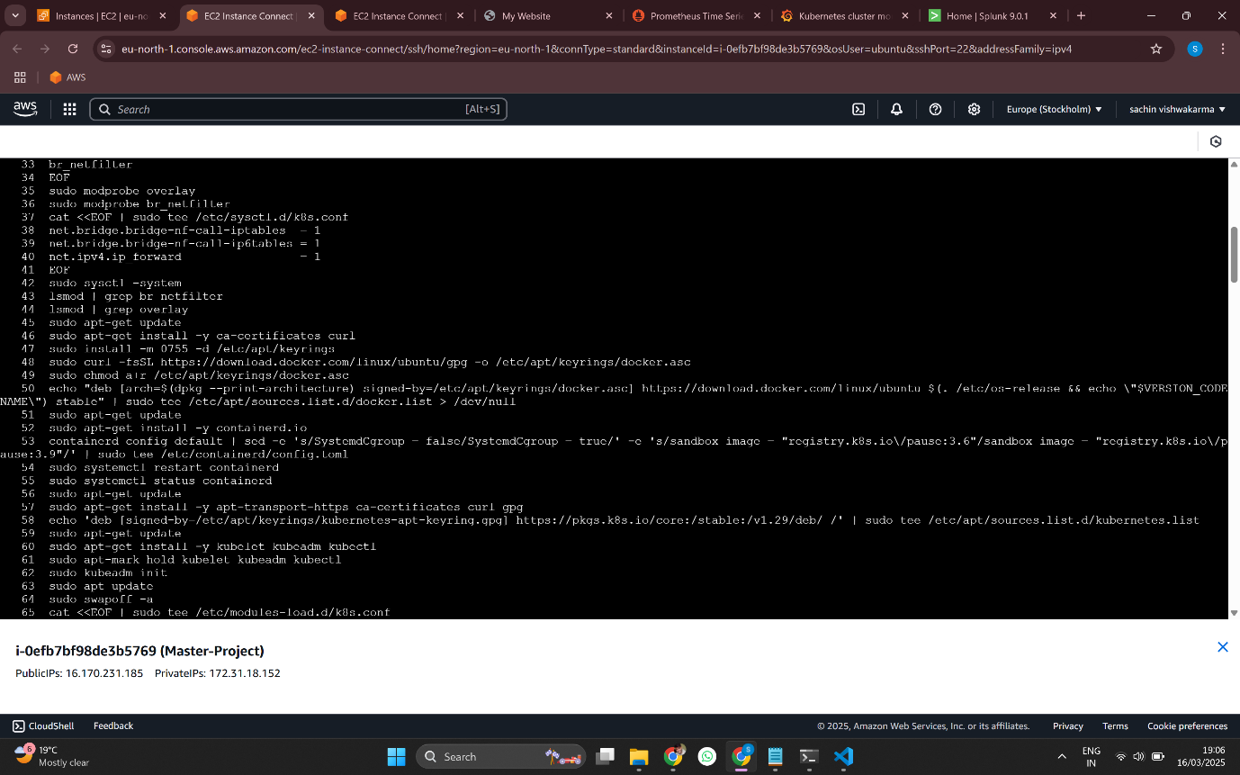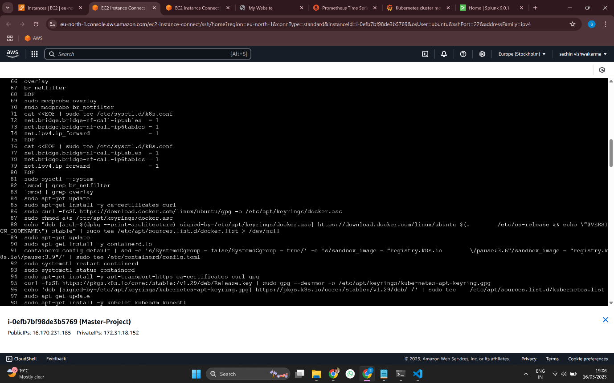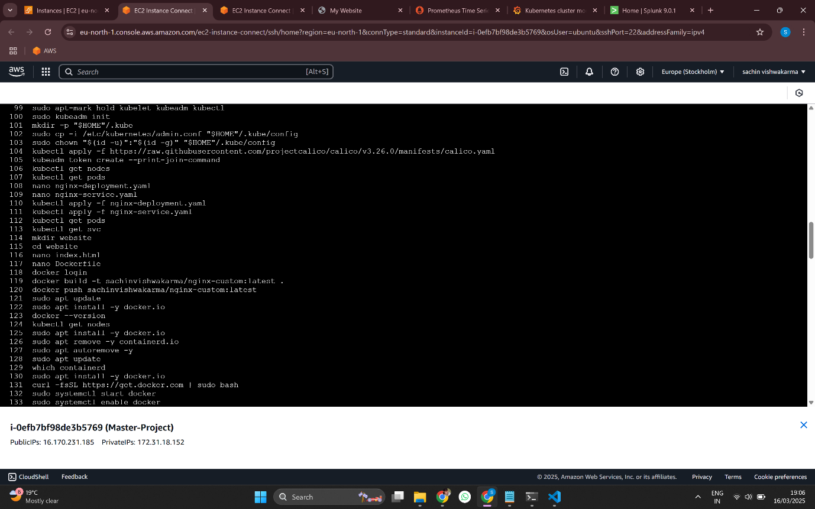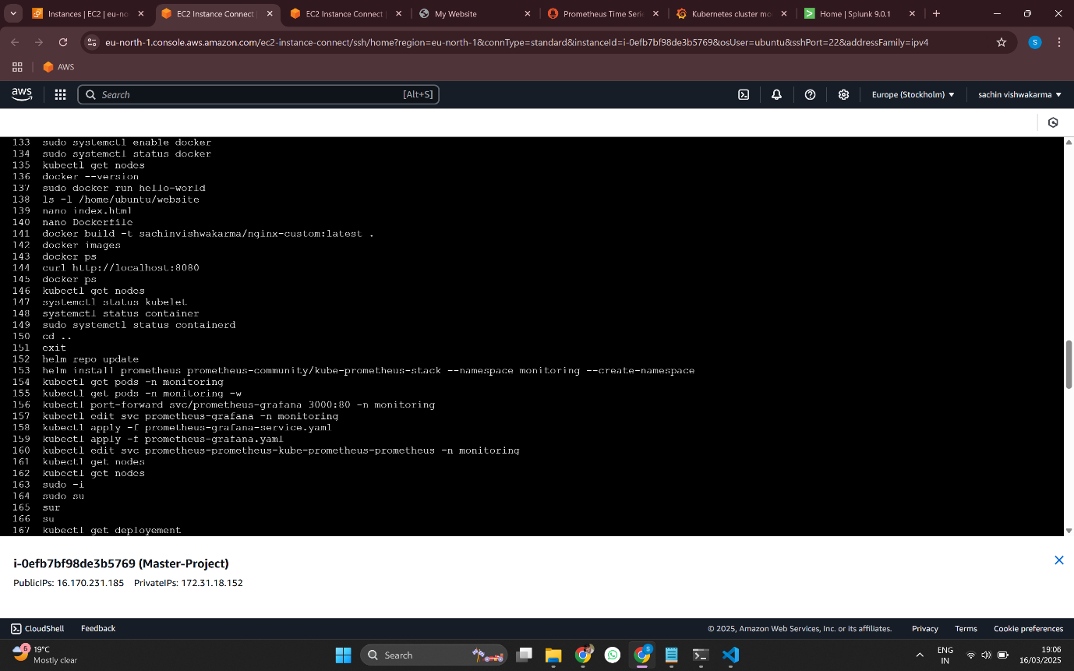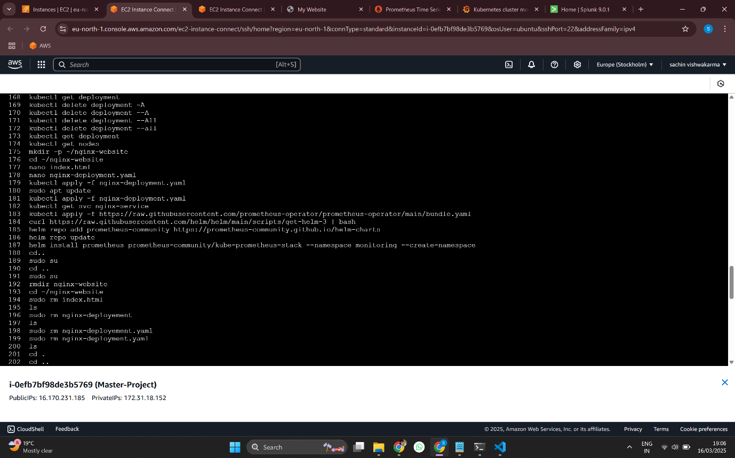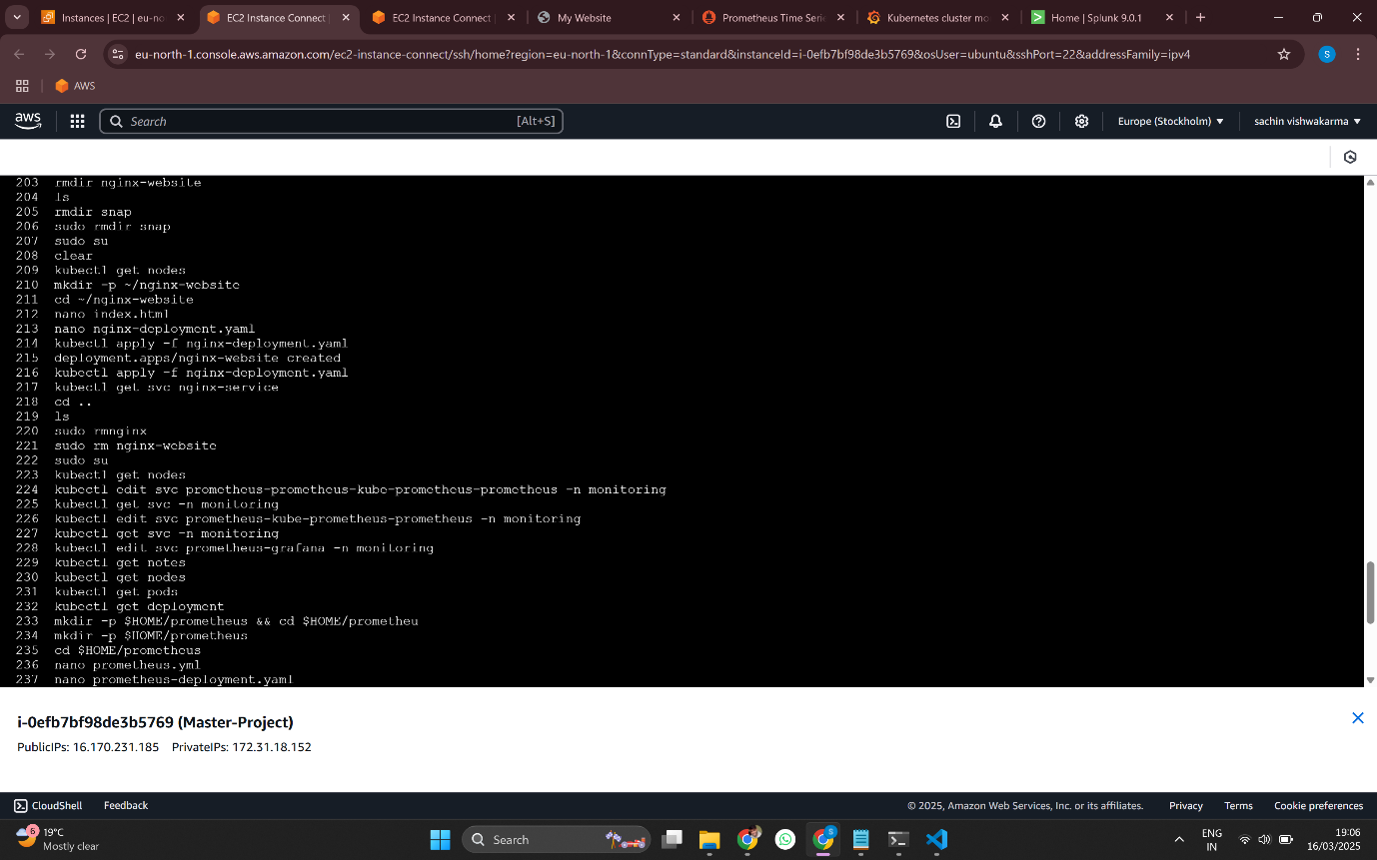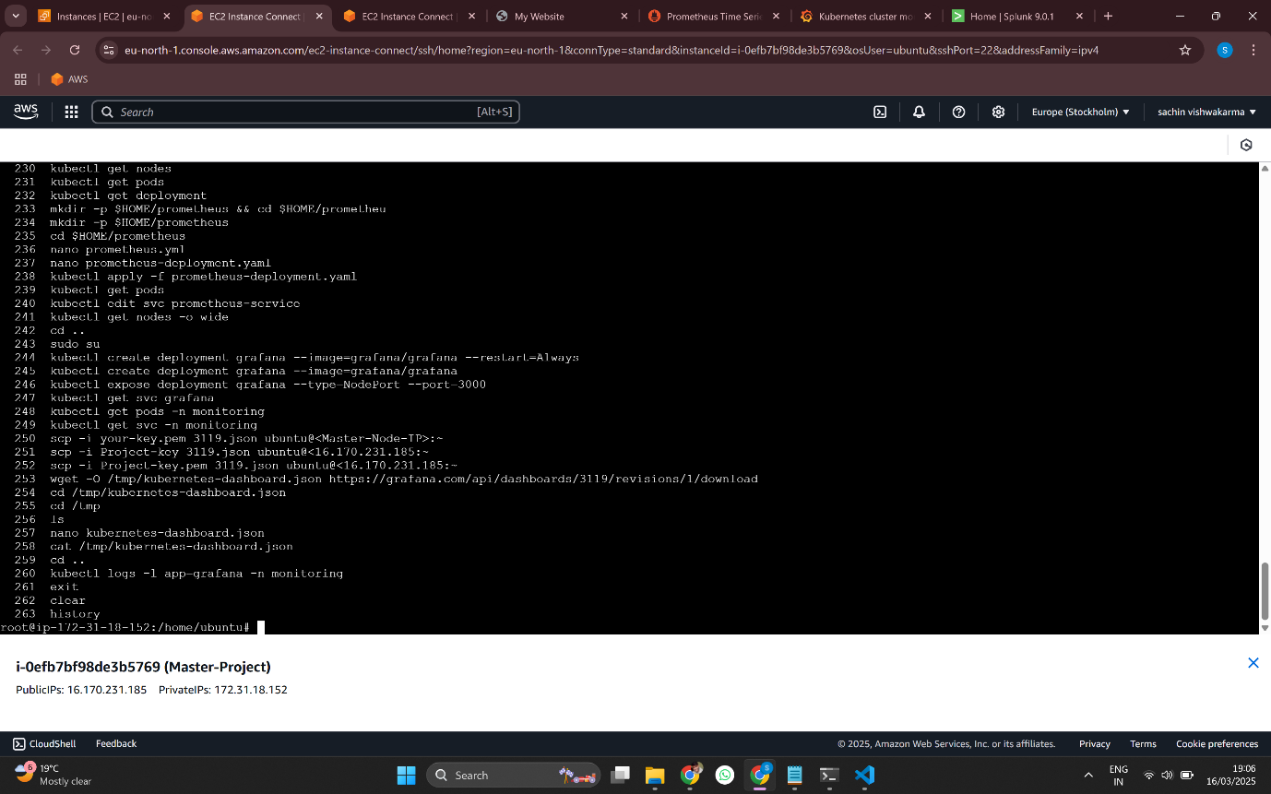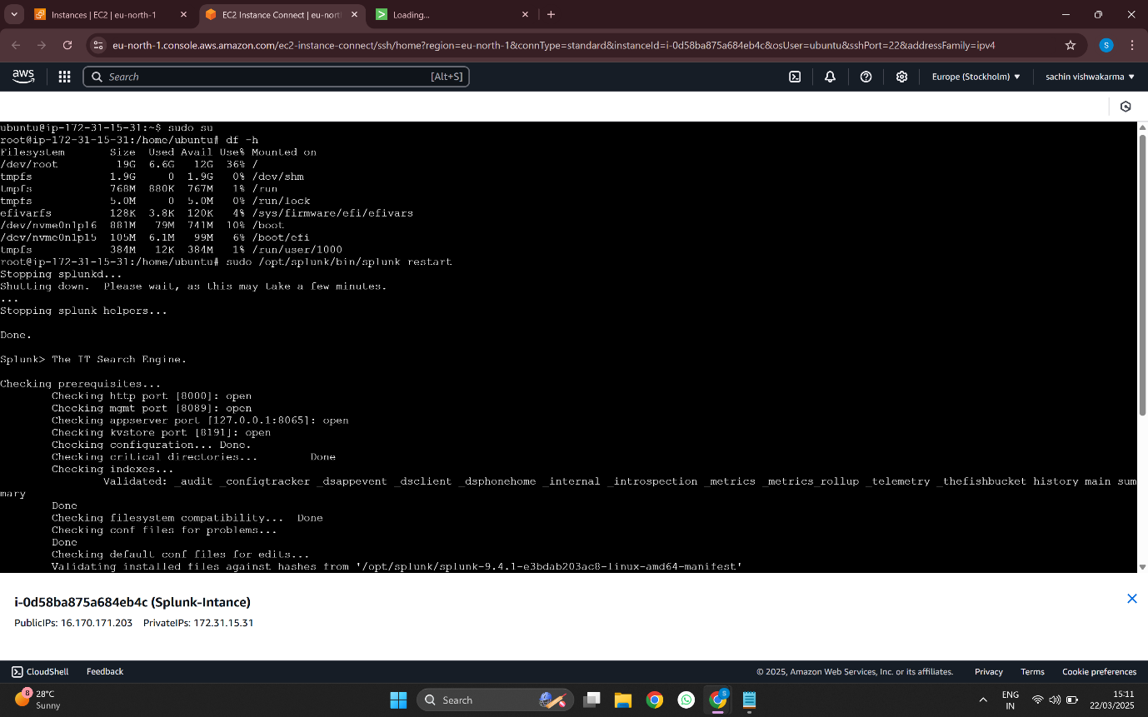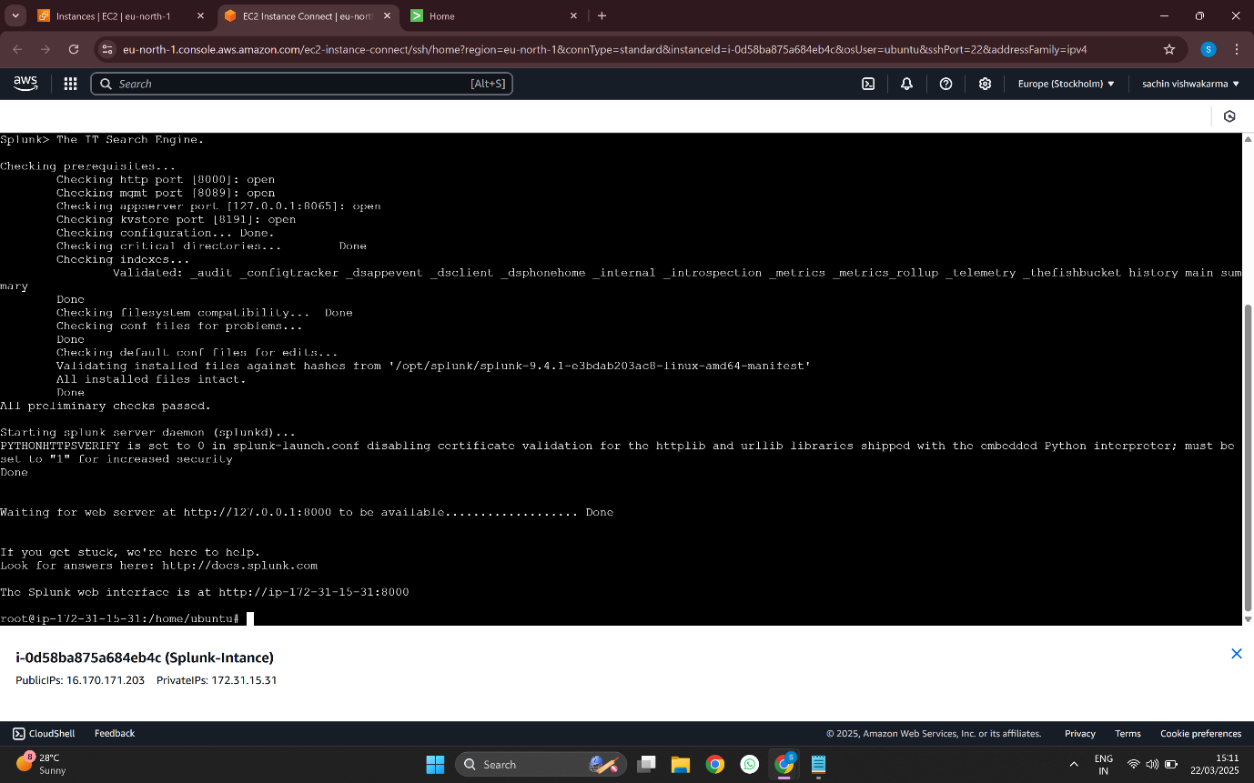

* **Slave’s Command:-**

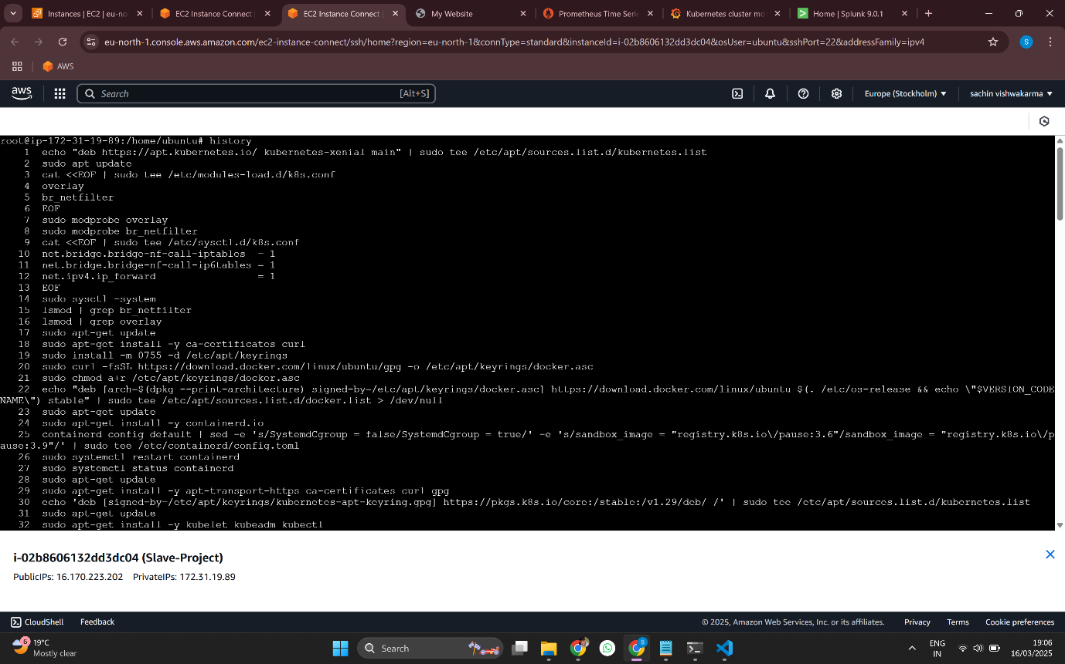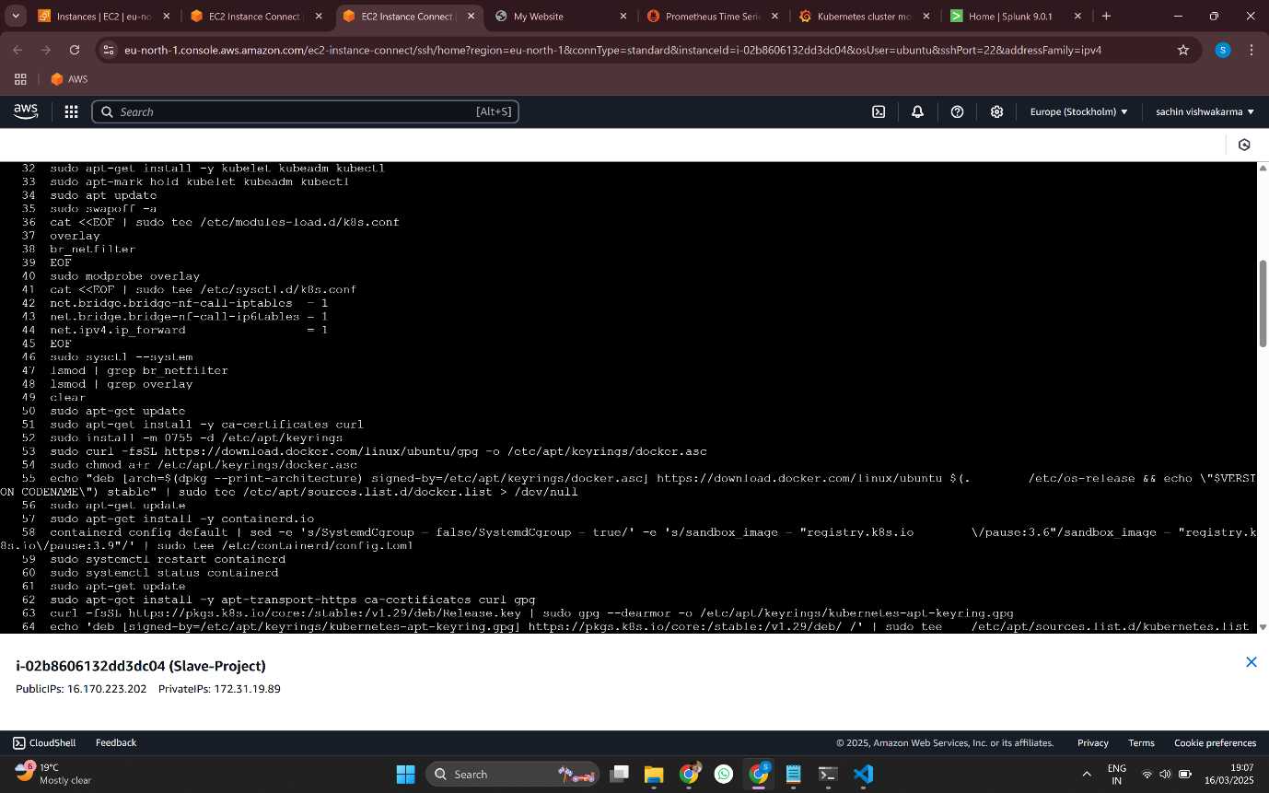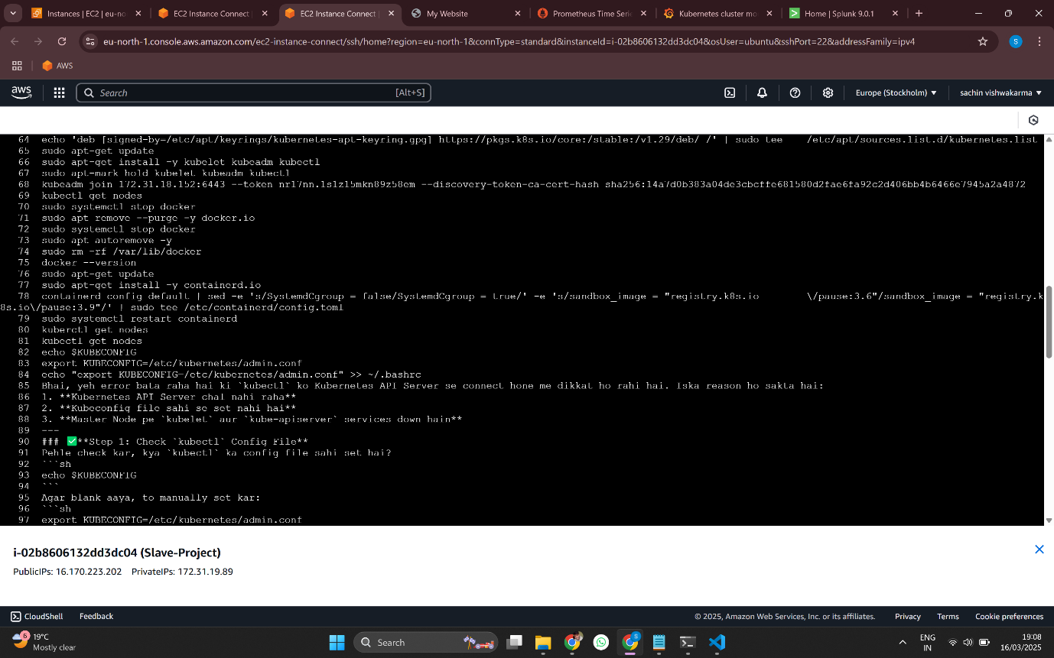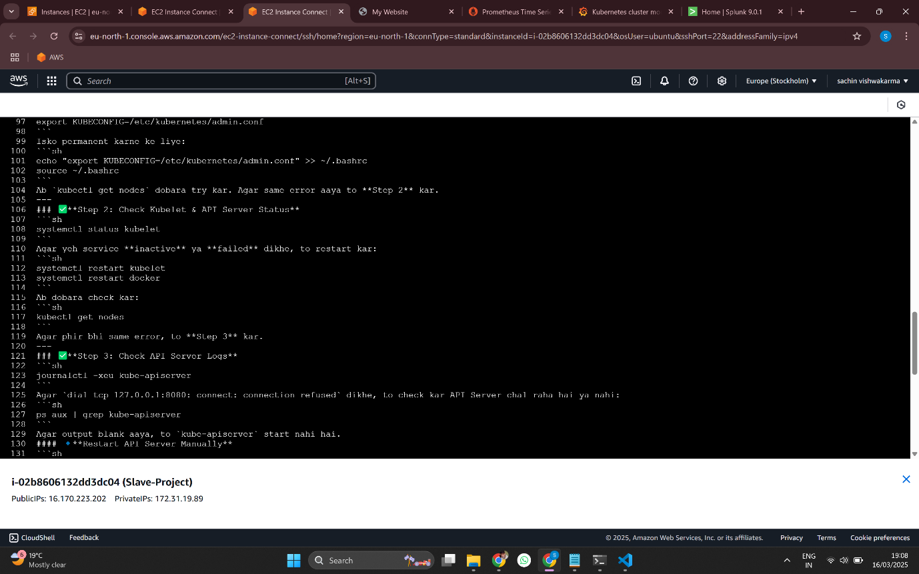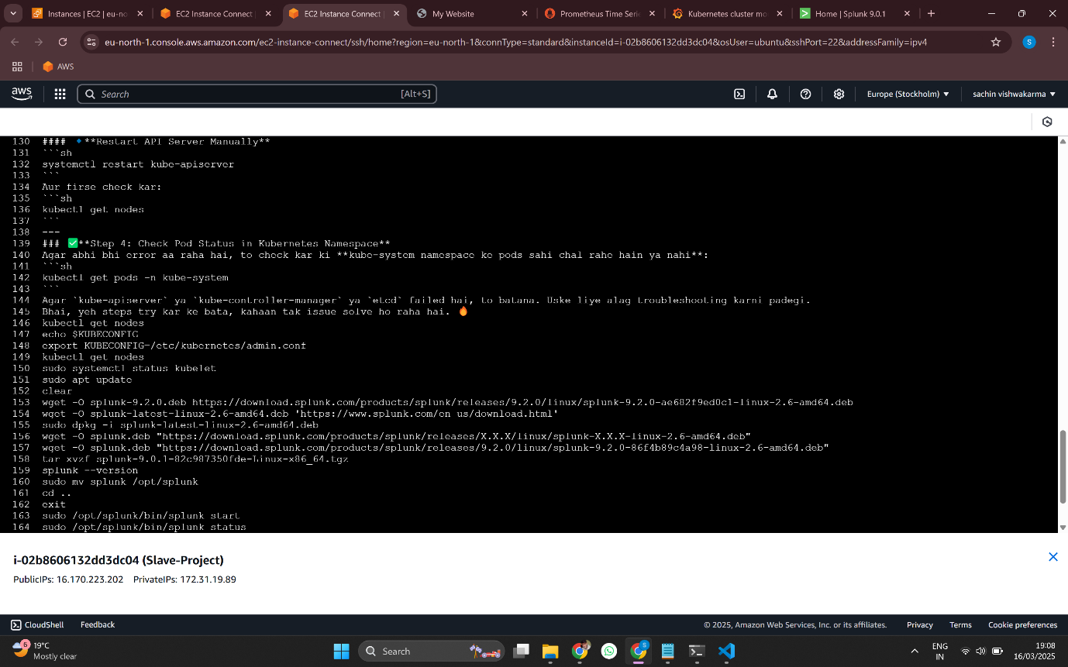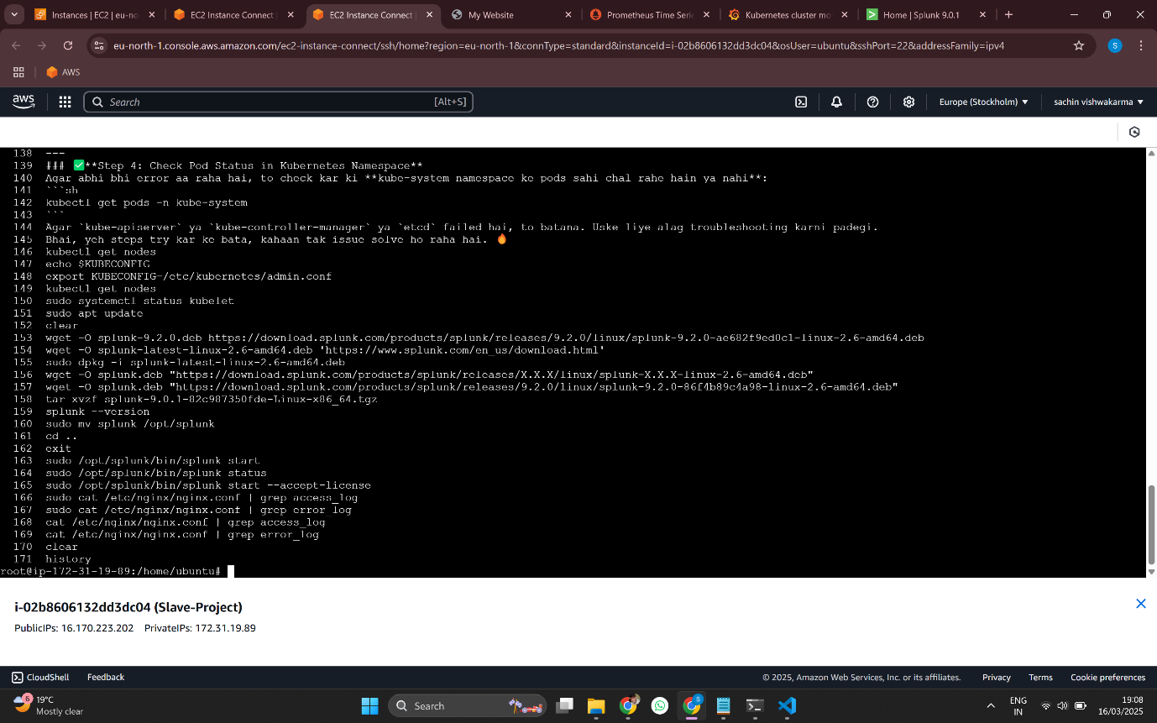

* **Result:-**

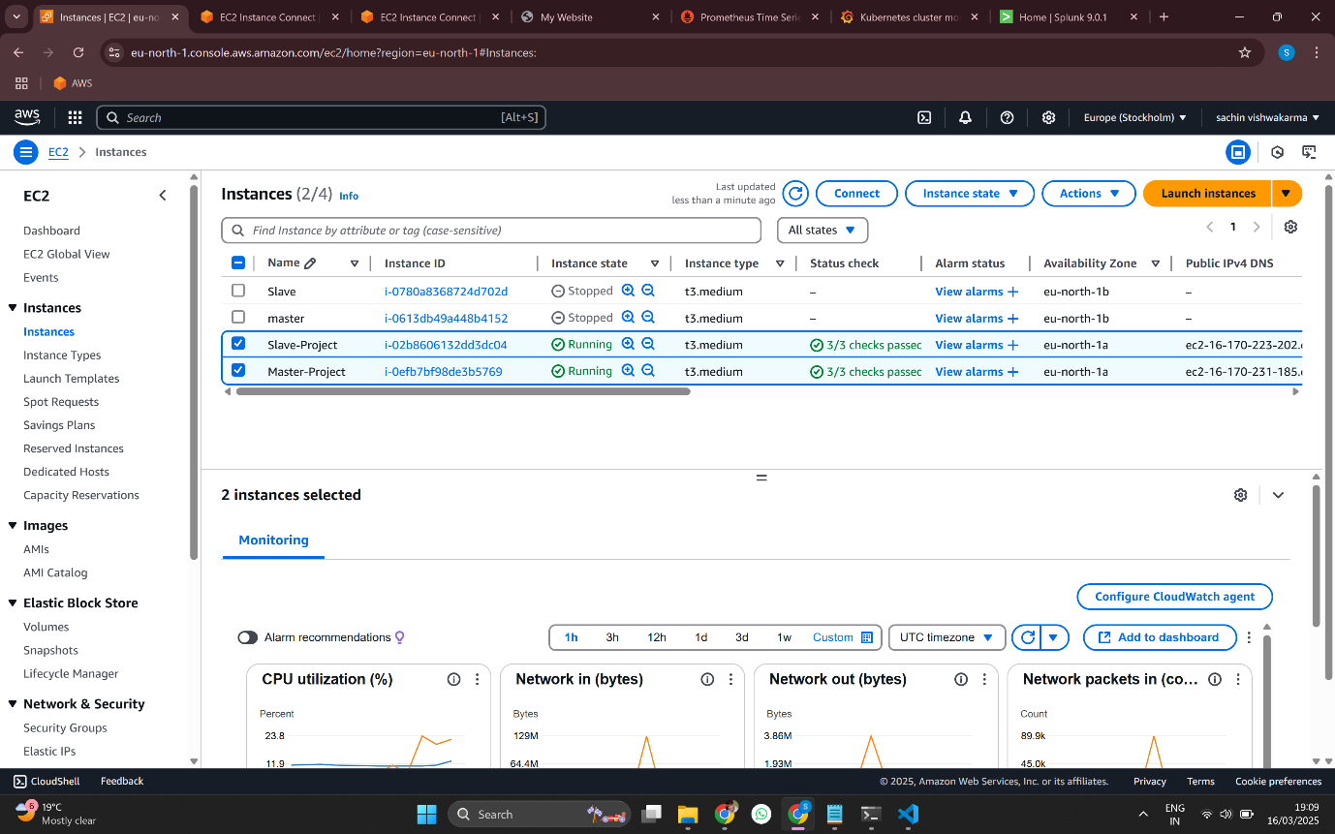

* **My Static-Website:-**



* **Prometheus-Dashboard:-**

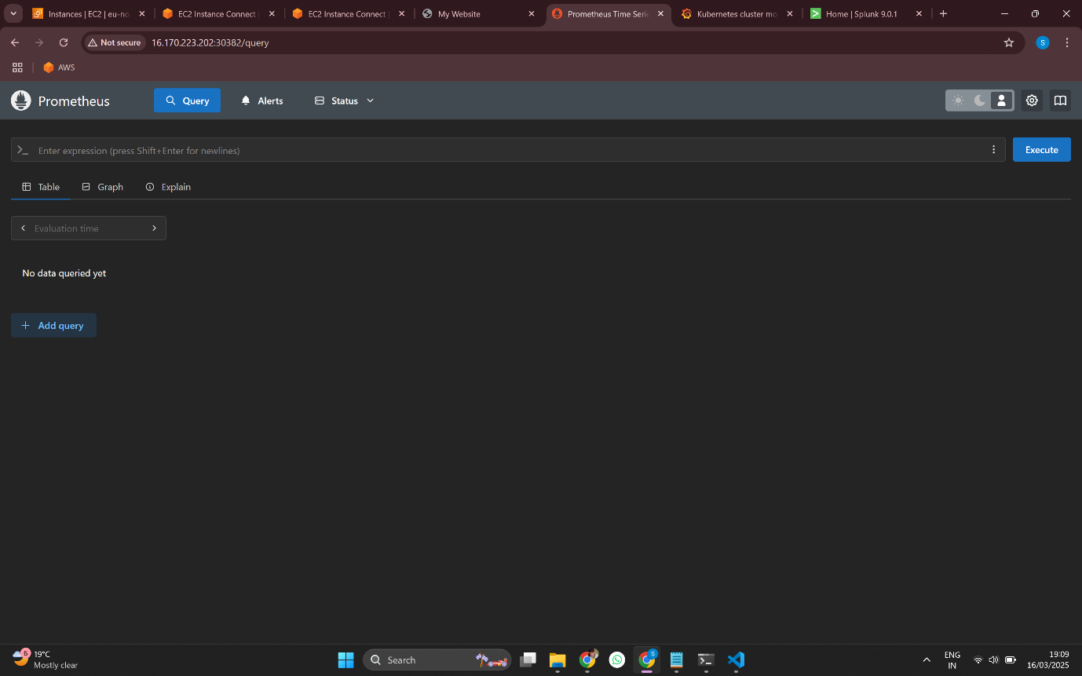

* **Grafana-Dashboard:-**

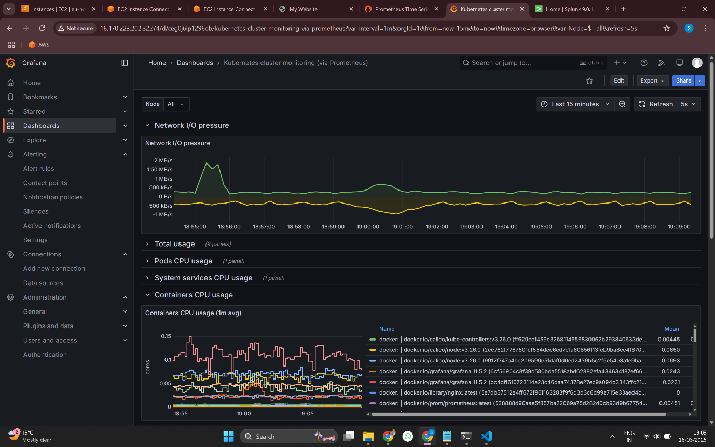

* **Splunk-Dashboard:-**

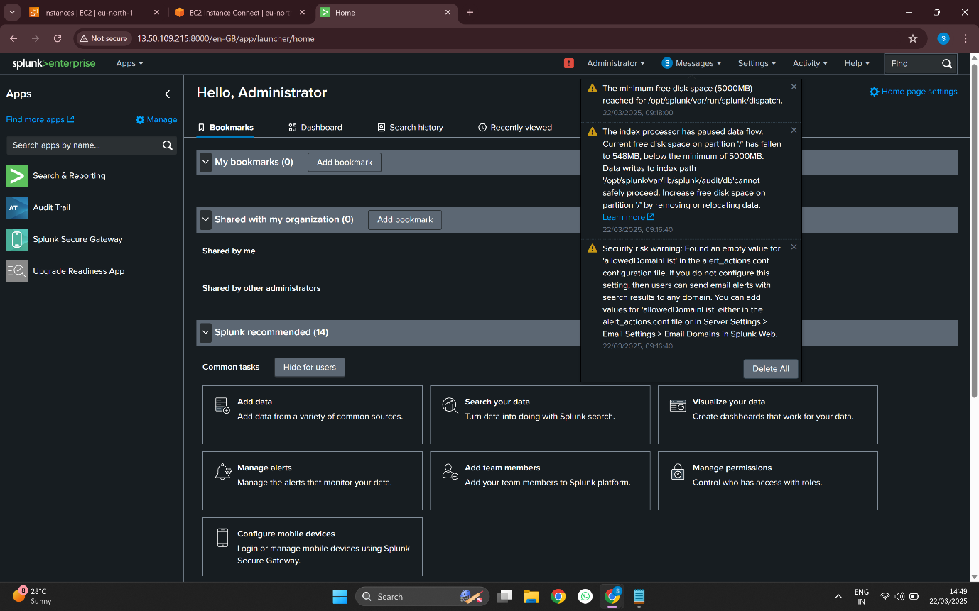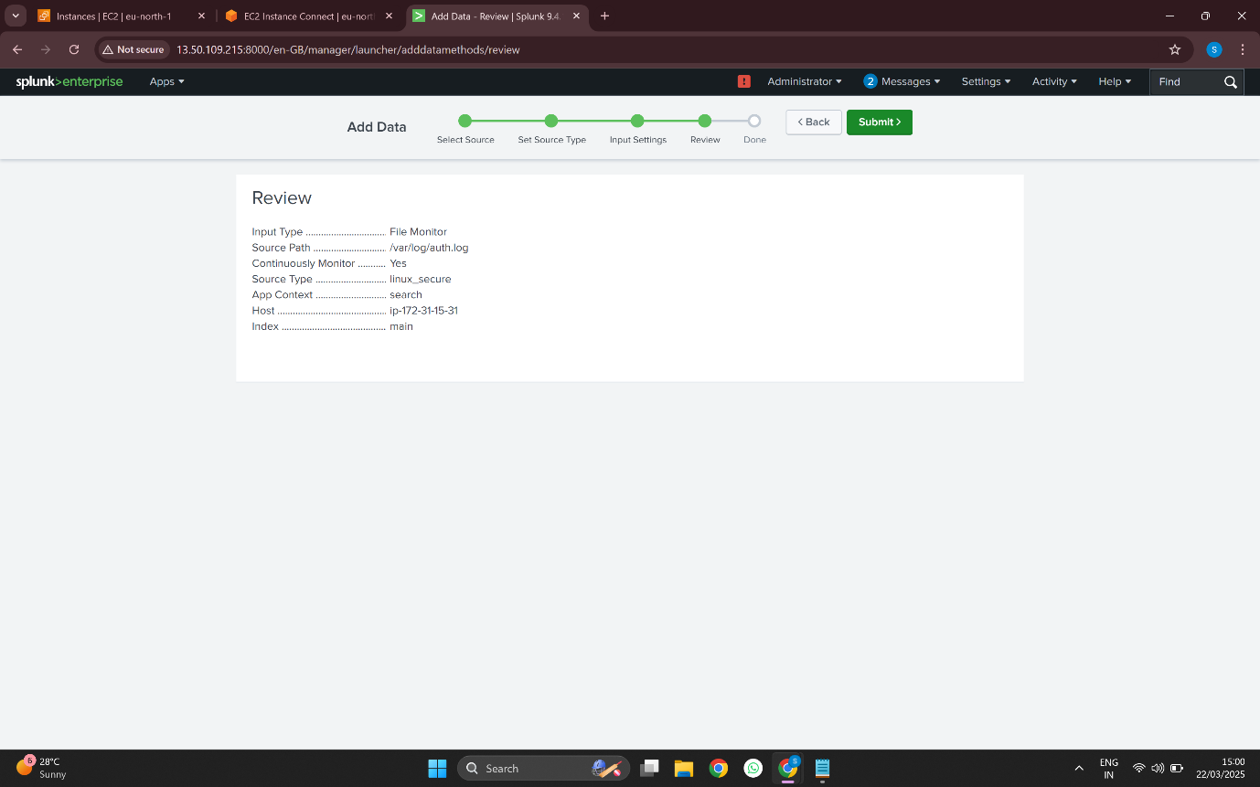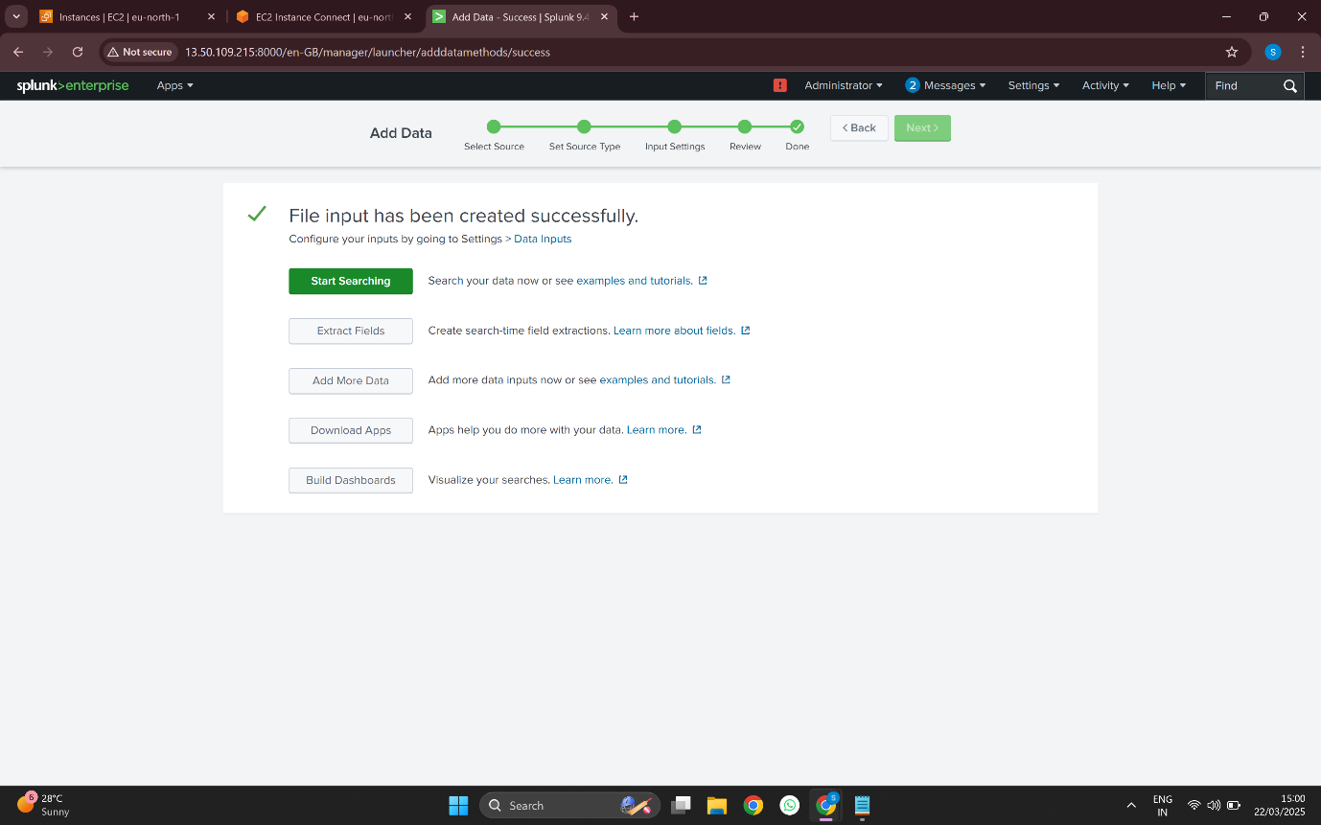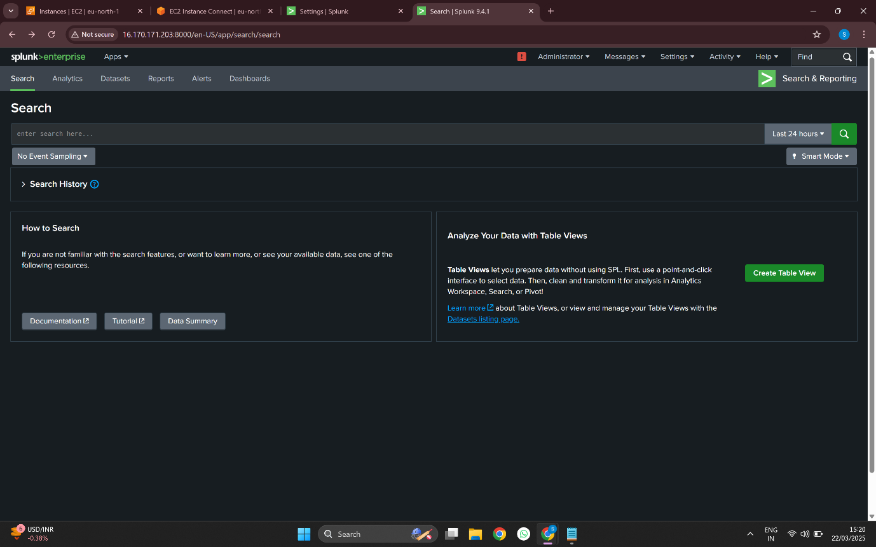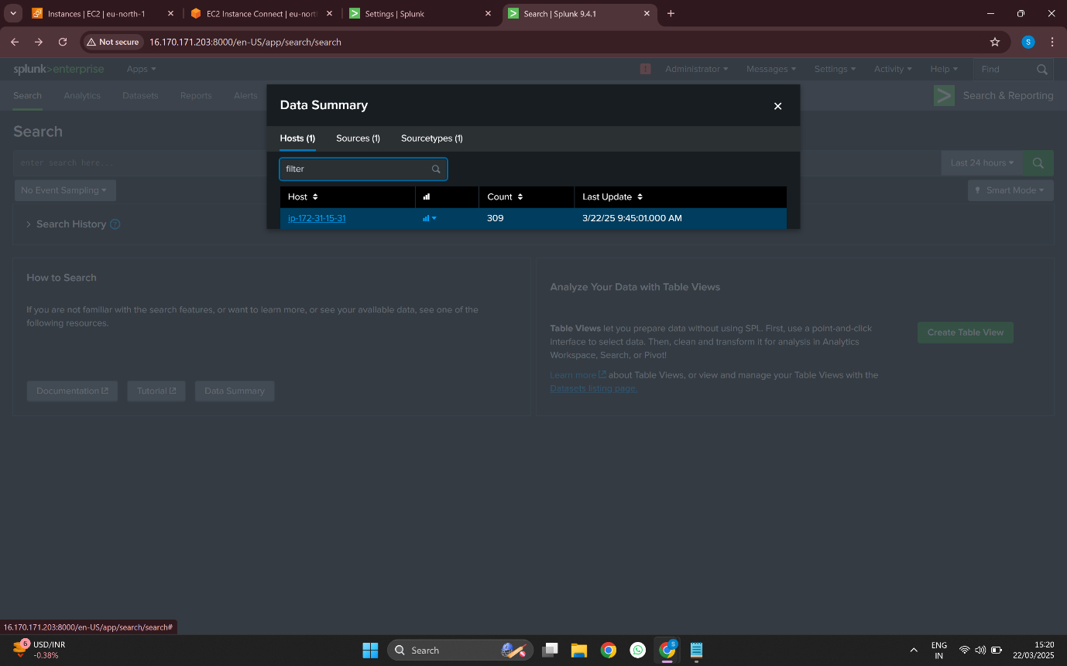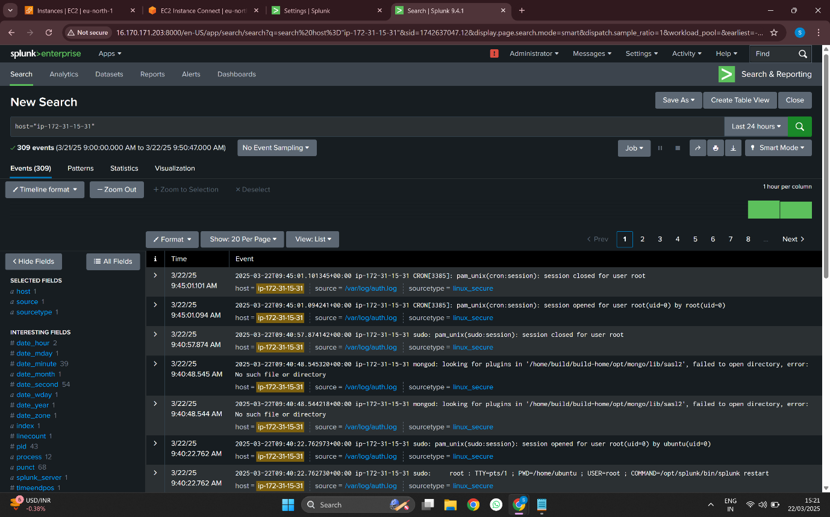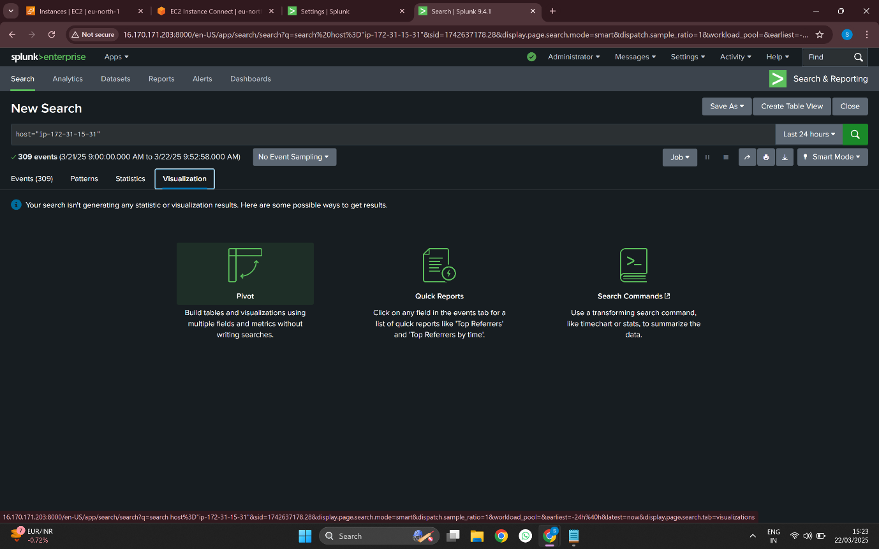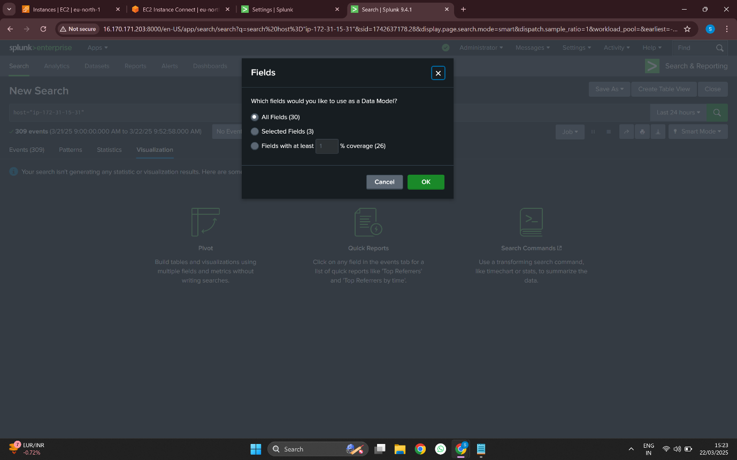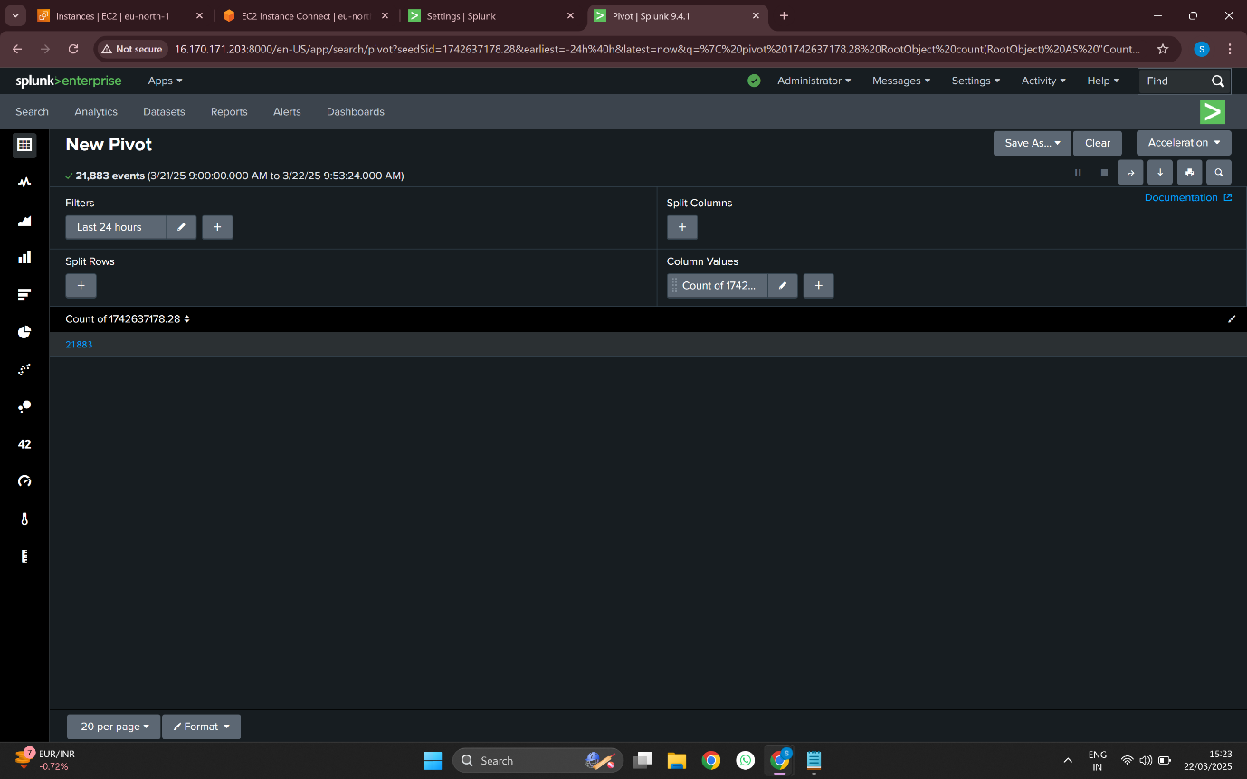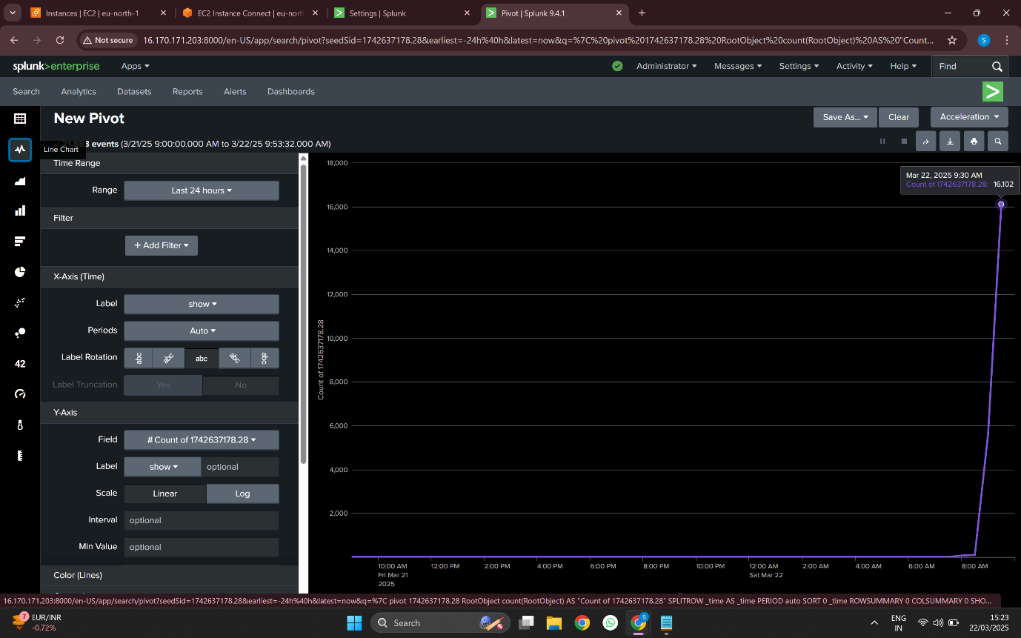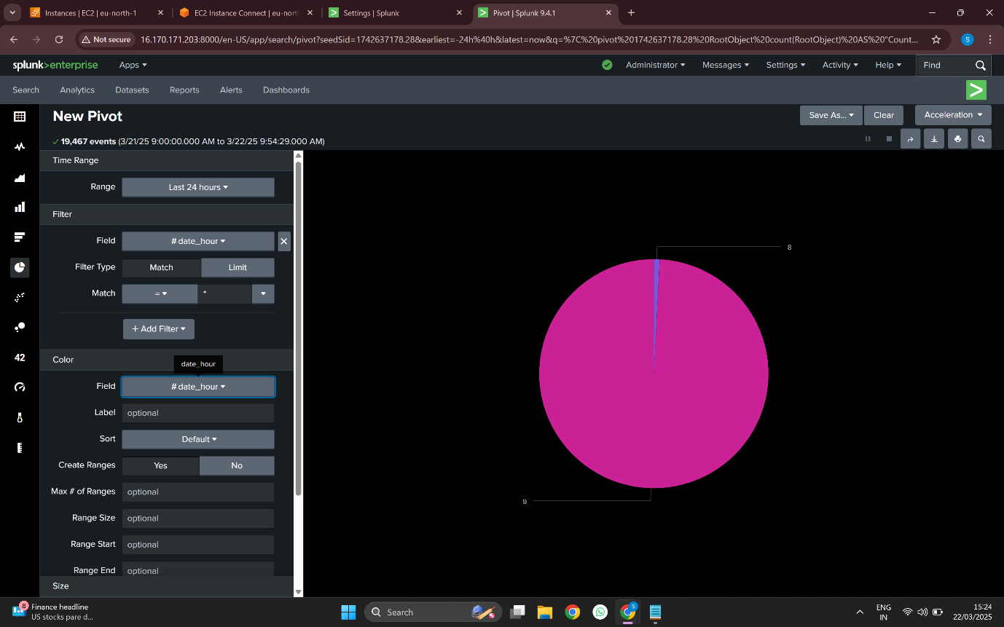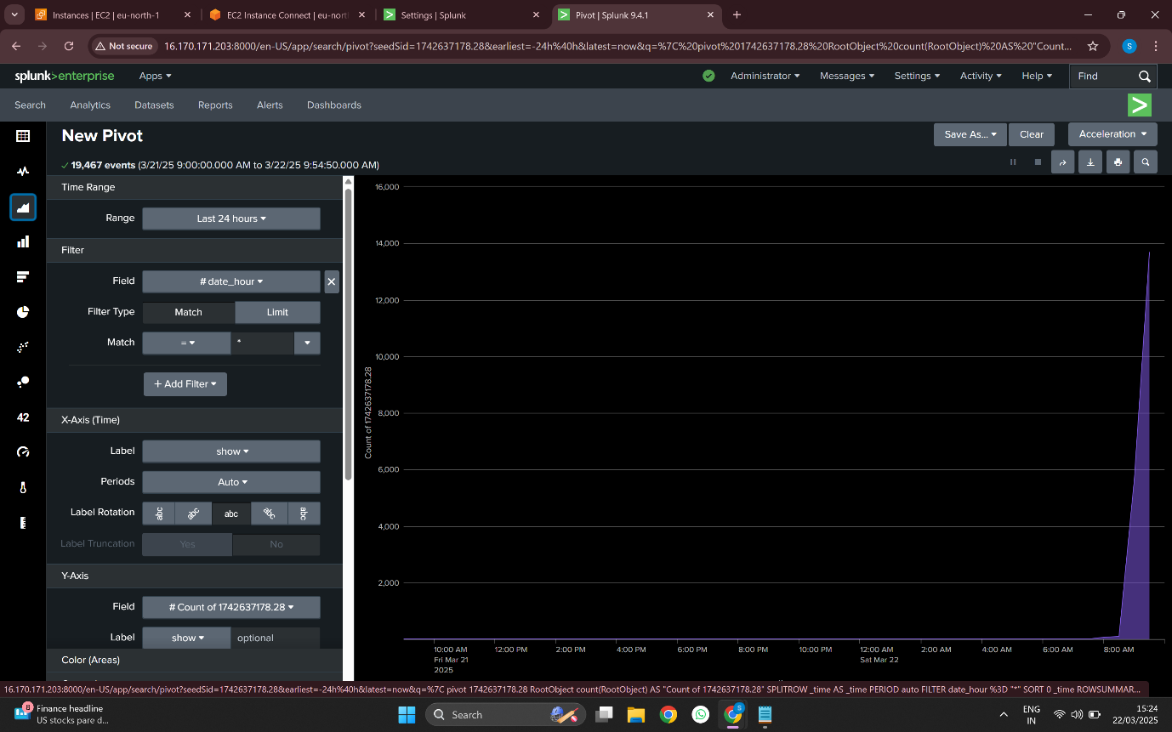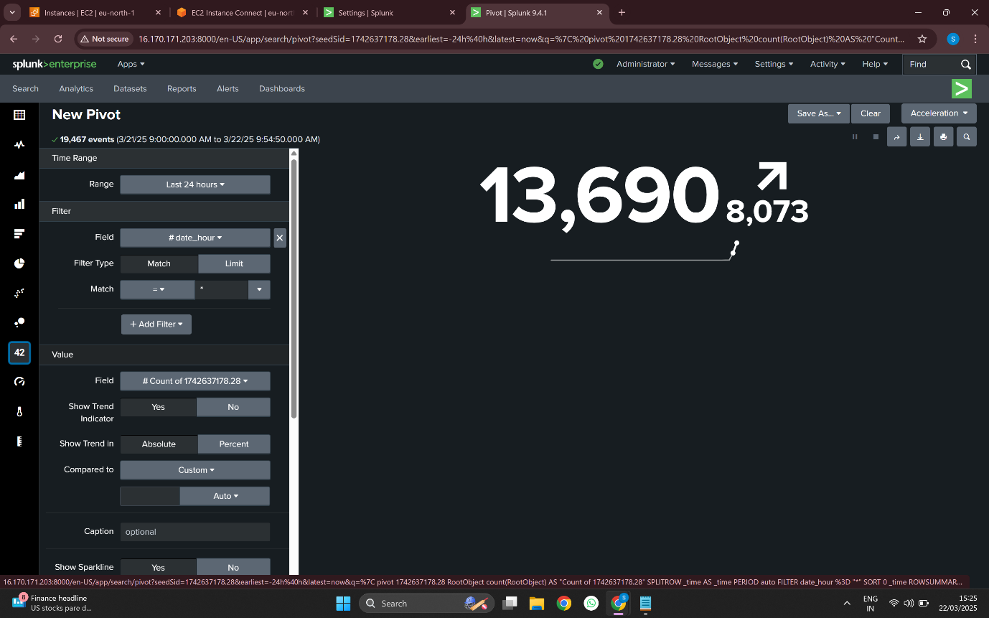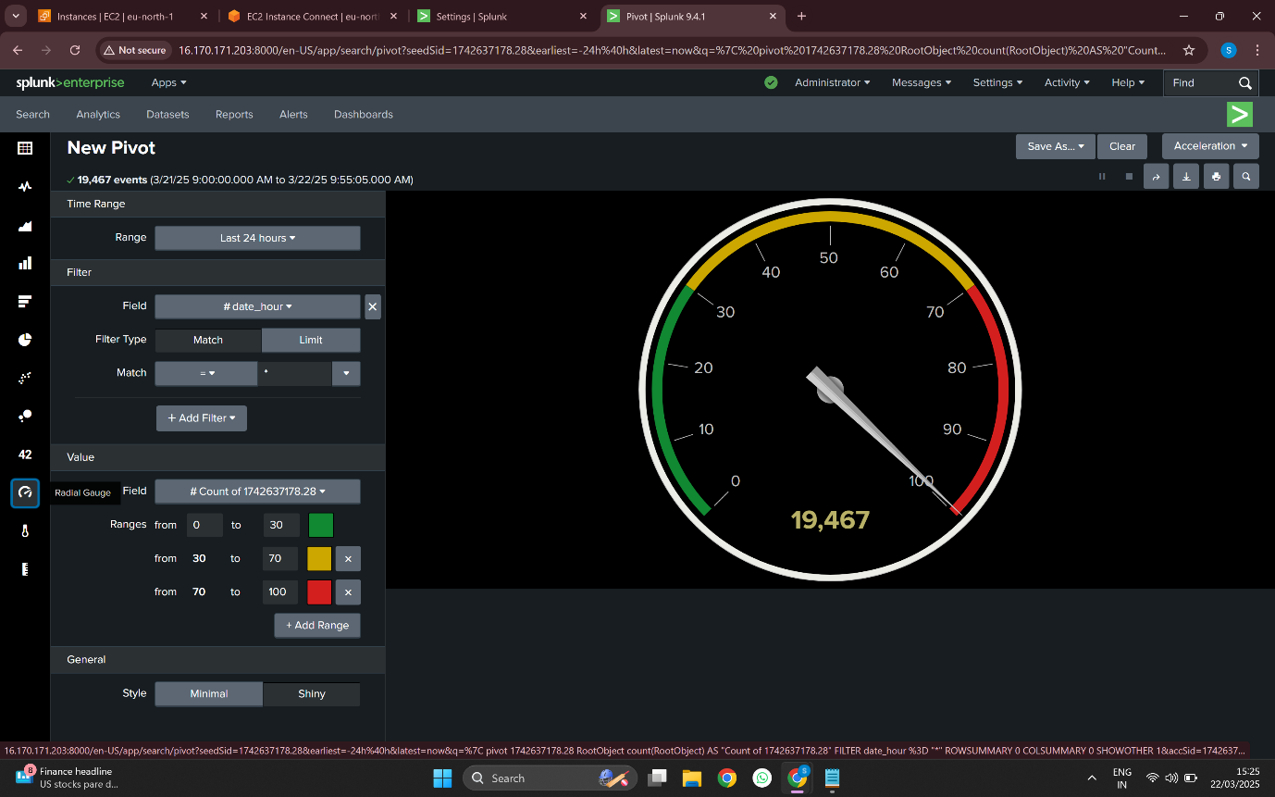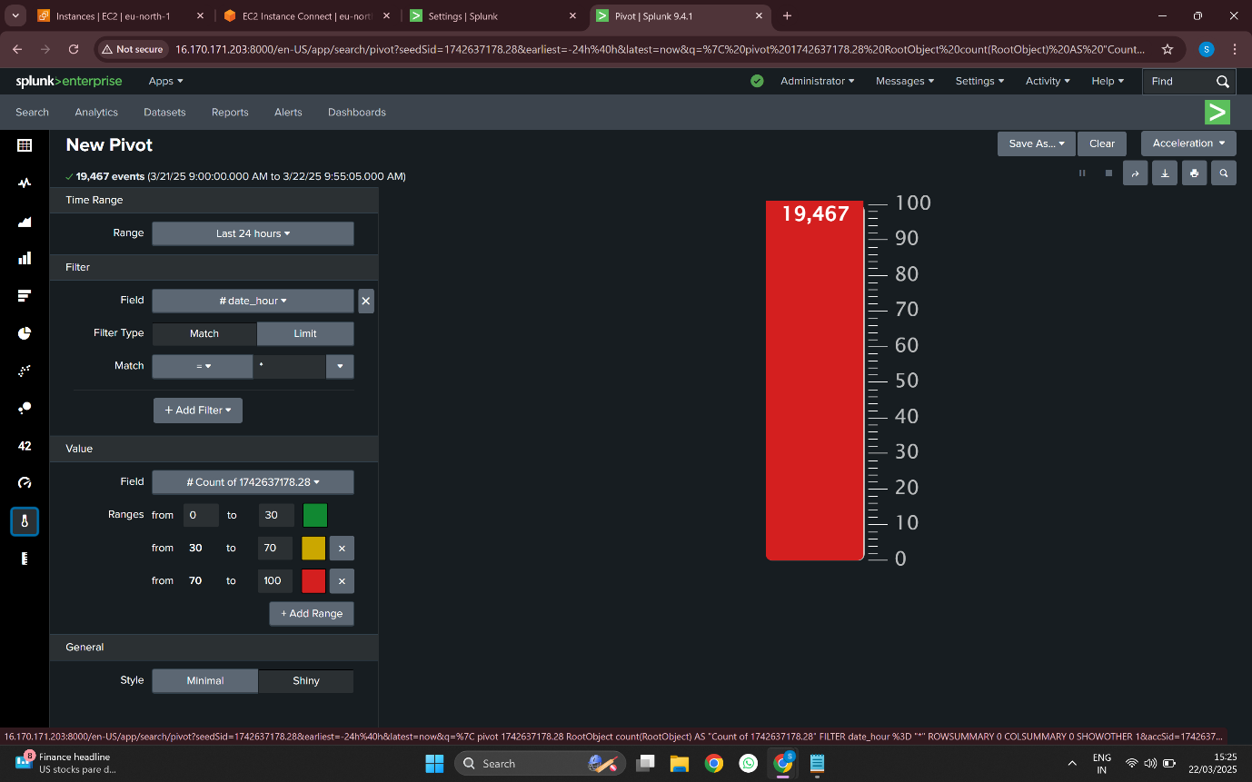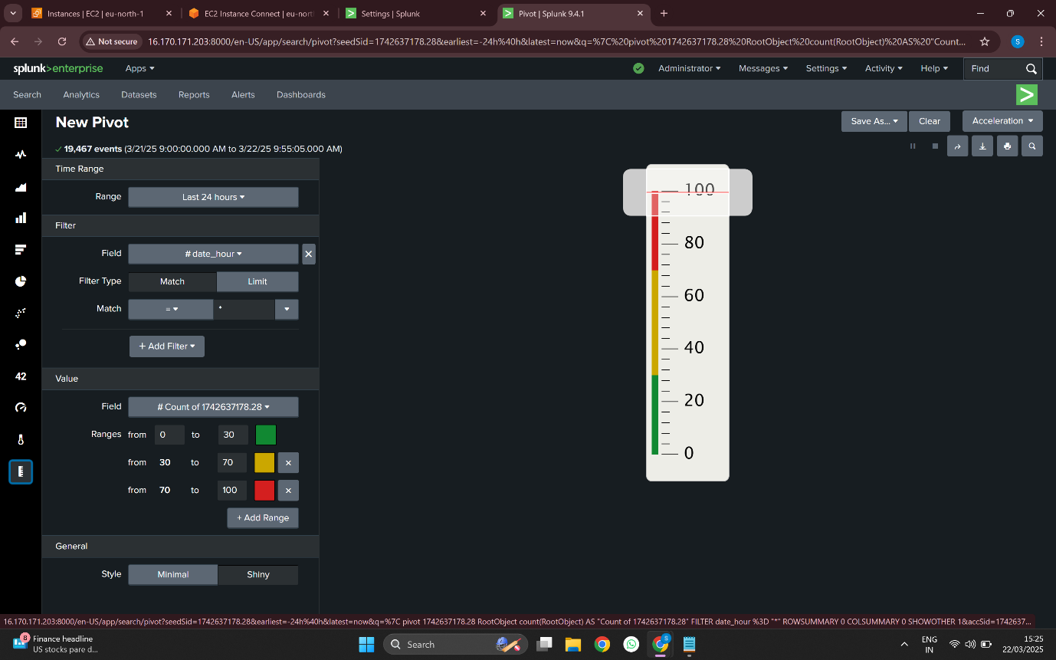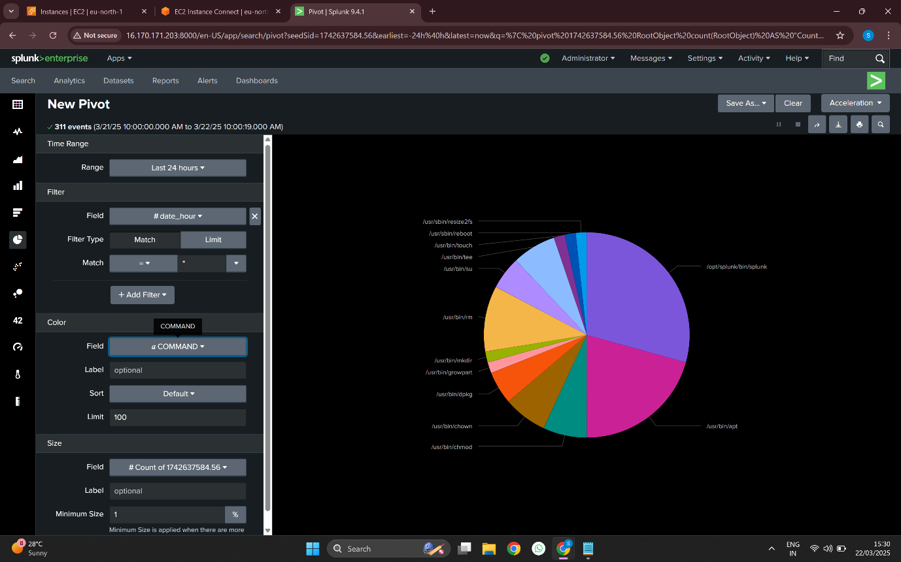

**8. Bibliography (References)**

1. **Kubernetes Documentation –**[**https://kubernetes.io/docs/**](https://kubernetes.io/docs/)
2. **Prometheus Docs –**[**https://prometheus.io/docs/**](https://prometheus.io/docs/)
3. **Grafana Docs –**[**https://grafana.com/docs/**](https://grafana.com/docs/)
4. **Splunk Documentation –**[**https://docs.splunk.com/**](https://docs.splunk.com/)
5. **NGINX Docs –**[**https://nginx.org/en/docs/**](https://nginx.org/en/docs/)
6. **ChatGPT by OpenAI –**[**https://chat.openai.com**](https://chat.openai.com/)